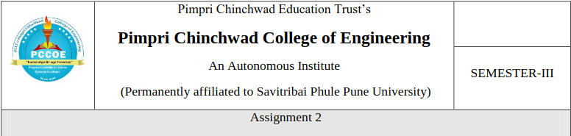

**Assignment 2**

Q1] Create StudentManagement database.

CREATE DATABASE studmanagement;

Q2] Create the Students table under StudentManagement database.

USE studmanagement;

CREATE TABLE Student_180 (

PRN INT PRIMARY KEY,

FirstName VARCHAR(50) NOT NULL,

LastName VARCHAR(50) NOT NULL,

MiddleName VARCHAR(50) NULL,

Year INT NOT NULL,

Email VARCHAR(100) UNIQUE,

Age INT NOT NULL,

Department VARCHAR(100) NOT NULL

);

Q3] Insert records into the Students table

INSERT INTO Student_180 (PRN, FirstName, LastName, MiddleName, Year, Email, Age, Department)

VALUES

(101, 'John', 'Doe', 'A.', 2, 'john.doe@example.com', 20, 'Computer Science'),

(102, 'Jane', 'Smith', 'B.', 1, 'jane.smith@example.com', 19, 'Electronics'),

(103, 'Alice', 'Johnson', NULL, 3, 'alice.johnson@example.com', 21, 'Mechanical'),

(104, 'Brod', 'Stud', 'B', 2, 'Brod.a@example.com', 20, 'Electronics');

Q4] Write a query to retrieve all records from the Students table.

SELECT * FROM Student_180;

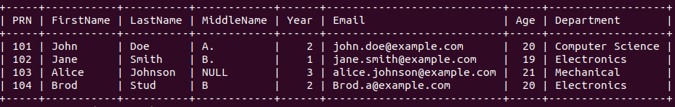

Q5] Write a query to update the Year of the student with PRN 102 to 2.

UPDATE Student_180

SET Year = 2

WHERE PRN = 102;

SELECT * FROM Student_180;

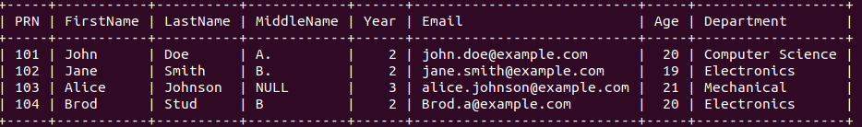

Q6] Write a query to delete the record of the student whose PRN is 103.

DELETE FROM Student_180

WHERE PRN = 103;

SELECT * FROM Student_180;

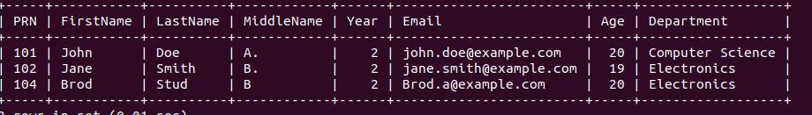

Q7] Write a query to delete the Students table from the StudentManagement database.

DROP TABLE Student_180;

Q8] Write a query to add a new column PhoneNumber of type VARCHAR(15) to the Students

table.

ALTER TABLE Student_180

ADD PhoneNumber VARCHAR(15);

SELECT * FROM Student_180;

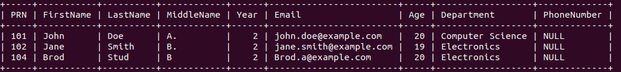

Q9] Write a query to retrieve all distinct departments from the Students table.

SELECT DISTINCT Department FROM Student_180;

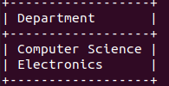

Q10] Write a query to find number of distinct departments from the Students table.

SELECT COUNT(DISTINCT Department) FROM Student_180;

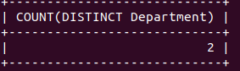

Q11] Write a query to retrieve the distinct years in which students are enrolled.

SELECT DISTINCT Year FROM Student_180;

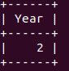

Q12] Write a query to retrieve all distinct ages of students in the "Computer Science"

department.

SELECT DISTINCT Age FROM Student_180

WHERE Department = 'Computer Science';



Q13] Write a query to retrieve distinct first names of students whose age is less than 21.

SELECT DISTINCT FirstName FROM Student_180

WHERE Age < 21;

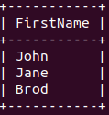

Q14] Write a query to retrieve the full details of students who are older than 20 years.

SELECT * FROM Student_180

WHERE Age > 20;



Q15] Write a query to retrieve all students enrolled in their third year.

SELECT * FROM Student_180

WHERE Year = 3;



Q16] Write a query to display the first and last names of students along with their department,

but only for students whose PRN is greater than 101.

SELECT FirstName, LastName, Department FROM Student_180

WHERE PRN > 101;

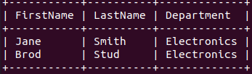

Q17] Write a query to fetch the first names and email addresses of all students in the

"Electronics" department.

SELECT FirstName, Email FROM Student_180

WHERE Department = 'Electronics';

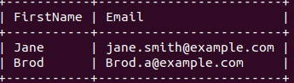

Q18] Write a query to fetch details of students in the "Computer Science" department who are

older than 19

SELECT * FROM Student_180

WHERE Department = 'Computer Science' AND Age > 19;



Q19] Write a query to remove all records from the Students table without deleting the

structure of the table.

DELETE FROM Student_180;

SELECT * FROM Student_180;





Q20] Write a query to delete the Students table from the StudentManagement database.

DROP TABLE Student_180;